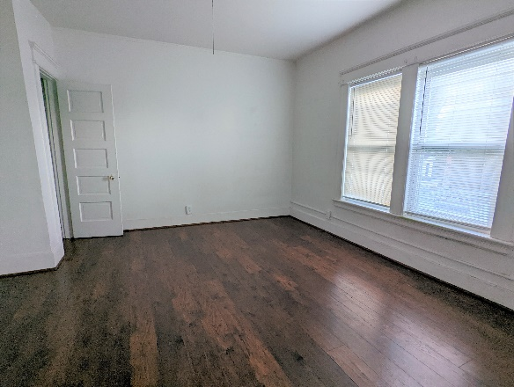
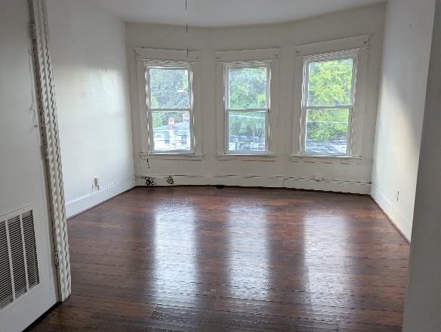
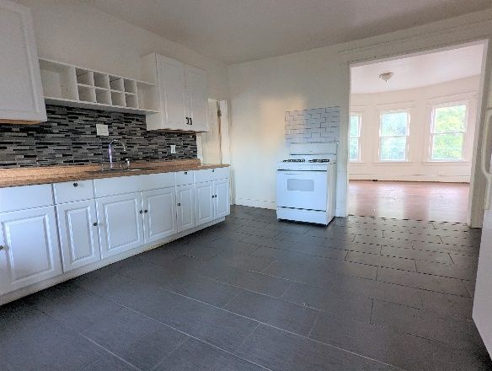
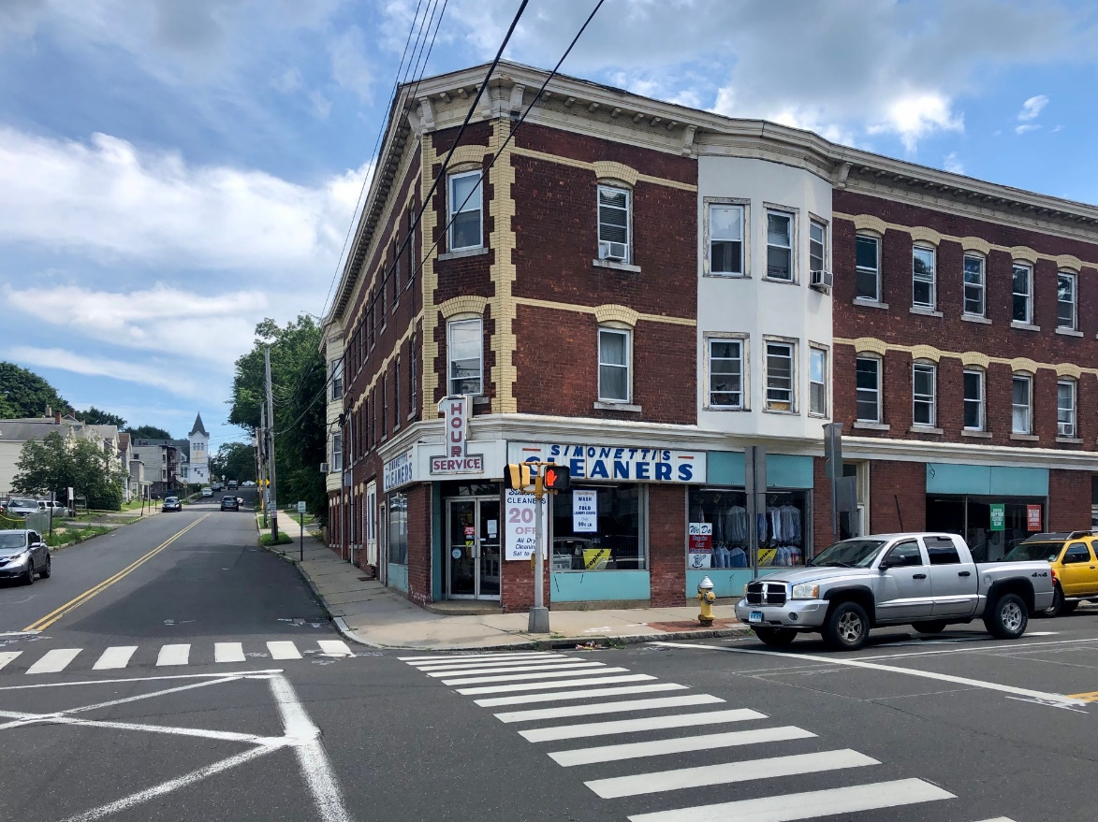




$1,600/month
1,300+/- sf two Bedroom Residential apartment in mixed-use building on third floor of 70 Center St. in Shelton, CT. Unit recently remodeled inside and available for immediate occupancy. It consists of two bedrooms, living room, kitchen and a full bath. Unit is located in the heart of thriving downtown Shelton within walking distance to shops, services and restaurants. On bus route and near Metro North Shelton/Derby railroad station, Route 8 & 34.
2 Total Bedrooms
1 Full Bath
Third Floor
Full Kitchen
Living Room
Rental Rate Includes water & sewer

Residential Apartment
70 Center St #8, Shelton
Please call to arrange a private viewing Steve Hodson 203-268-7743 www.hodsonrealty.com
For

